**YOU = BEST SELLING AUTHOR.**

Image how potential employers and potential (or current)

customers will react when you give them this completed book in 6 months!

Are you ready to do this? Yes! NO LIMITS : )

This is the template I used to write my Networking and 101 Crucial Lessons books.

It is 6 inches wide by 9 inches tall. When you are done, then go to these 3 websites:

1: In electronic (Kindle) format, Amazon does all of the hard work by putting it online for free (see <https://kdp.amazon.com/> ).

2: In paper format, Amazon does all of the hard work by putting it online for free (see <https://www.createspace.com/> ).

3: In audio format, Amazon does all of the hard work by putting it online for free

(see <http://www.acx.com/> ).

This page is the cover page for your book. The cover image of your book is fun and easy to.

All you need to do is go to [www.fiverr.com](http://www.fiverr.com) and ask someone to make it for you!

This guy creates all of the cover art for my books and Udemy.com courses: <https://www.fiverr.com/ultrakhan22>

[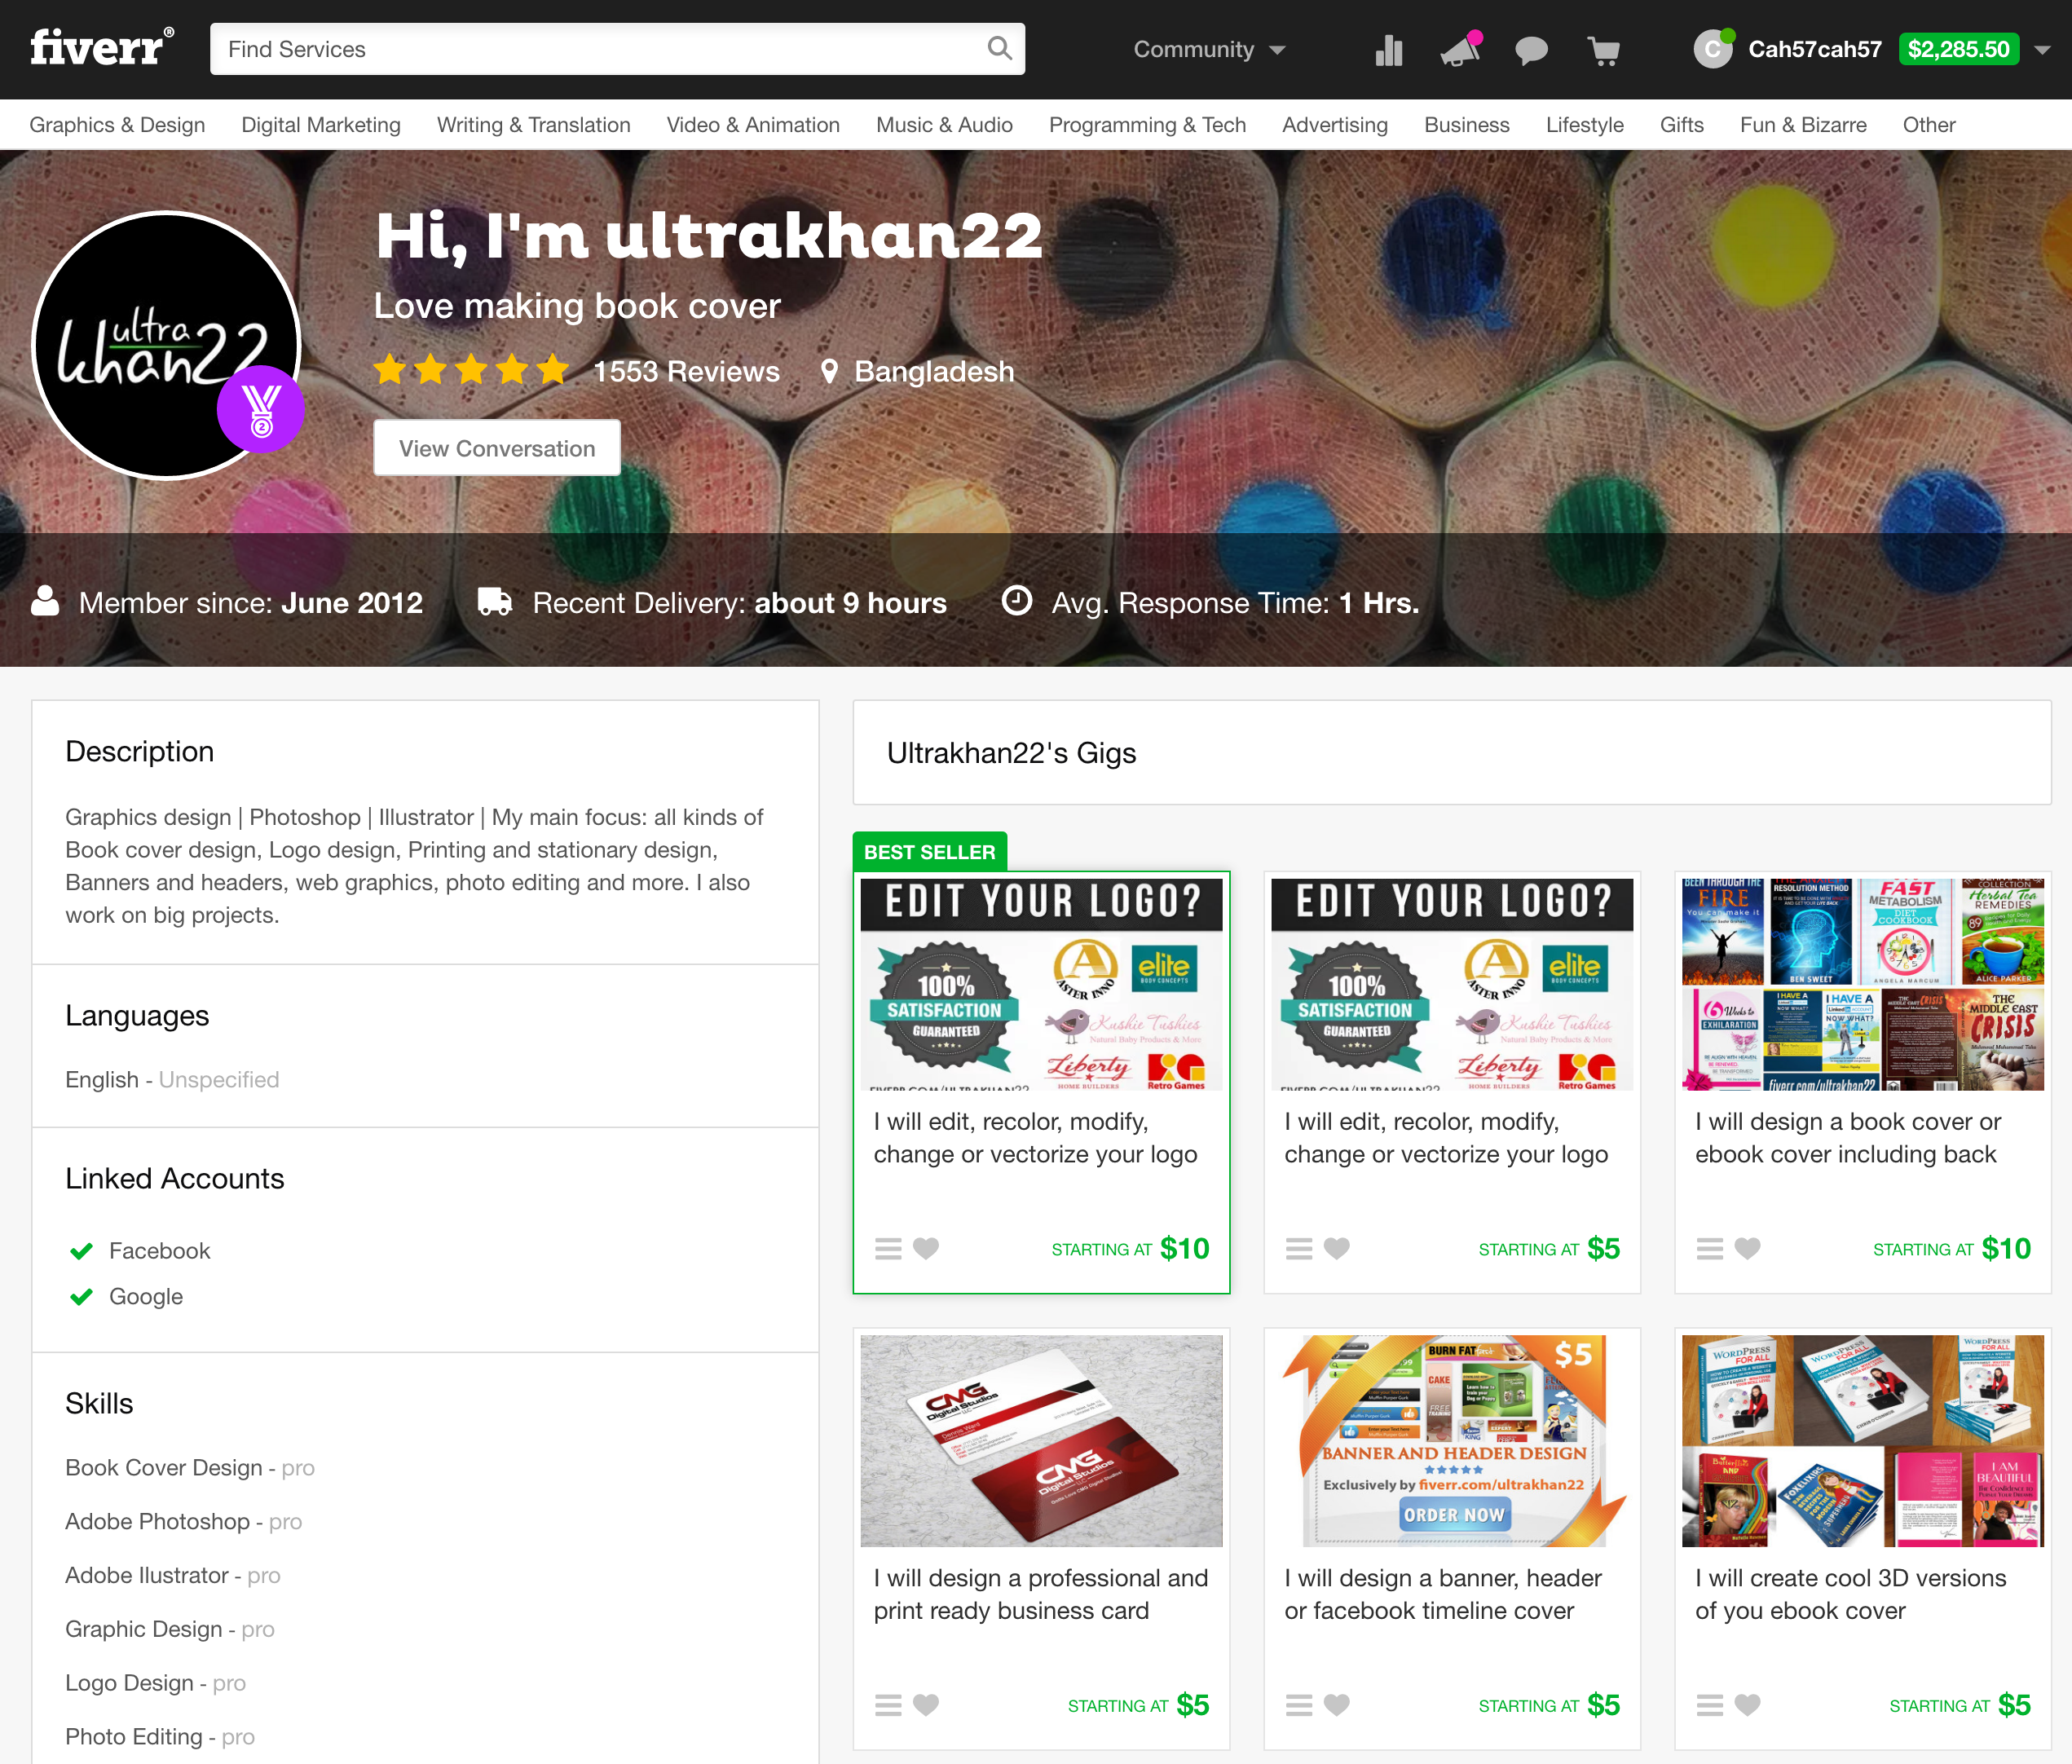](https://www.fiverr.com/ultrakhan22)

Put Your Book Title Here [and an image]



__________

by YOUR NAME

**Also available from Your Name:**

Put the names of books you already wrote [meaning you will fill in this section when you write your second book next year]

Title of Your Book Goes Here Again  
  
Copyright © 2016 by You or Your Company Name [go to [www.LegalZoom.com](http://www.LegalZoom.com) and they can copyright stuff for a few $100 or do it yourself for $35 at <http://www.copyright.gov/> ]

(Published by You or Your Company Name. For example: [www.HarounVentures.com](http://www.HarounVentures.com) )

All rights reserved. No part of this book may be reproduced or transmitted in any form or by any means without written permission from the author.

Dedication

To my Mom and Dad who gave me the faith and confidence to know in my heart that you can accomplish anything in life.

[it’s hard coming up with a better dedication than this eh ; ) ]

# Introduction & Thank You!

Your introduction to your book stuff goes here.

**Contents:   
[right click on the table below and select update when you want to refresh this. don’t type the contents below as the chapters are linked to here…again, please just right click it]**

Introduction & Thank You! 4

Section 1: Insert Title Here 6

Chapter 1 Title 7

Chapter 2 Title 9

Chapter 3 Title 11

Section 2: Insert Title Here 14

Chapter 4 Title 15

Chapter 5 Title 17

Chapter 6 Title 19

Conclusion 21

# Section 1: Insert Title Here

*"Put an inspirational quote here."*

*-Quote Author Name*

Chapter 1 Title

*"Put an inspirational quote here."*

*-Quote Author Name*

Chapter 1 text.

Chapter 2 Title

*"Put an inspirational quote here."*

*-Quote Author Name*

Chapter 2 text.

Chapter 3 Title

*"Put an inspirational quote here."*

*-Quote Author Name*

Chapter 3 text.

# Section 2: Insert Title Here

*"Put an inspirational quote here."*

*-Quote Author Name*

Chapter 4 Title

*"Put an inspirational quote here."*

*-Quote Author Name*

Chapter 4 text.

Chapter 5 Title

*"Put an inspirational quote here."*

*-Quote Author Name*

Chapter 5 text.

Chapter 6 Title

*"Put an inspirational quote here."*

*-Quote Author Name*

Chapter 6 text.

# Conclusion

*"Put an inspirational quote here."*

*-Quote Author Name*

**Thank your readers here. See the next page for my conclusion to my book.**

**Congratulations**!!!! Please enjoy networking as you take your career to the next level (‘*meet people, have fun and learn’*)!

Please watch the next steps here:

[HarounVentures.com/network27](http://www.harounventures.com/Network27)



**Please find your passion by networking**

**and live love life on your terms.**



*We need to change the lens by which we see the world.*

Thank you very much for your time, dedication and commitment,  
Chris Haroun : )